**AMRC GitHub**

Sign in to <http://amrcgithub/> from within the Sheffield network with your me1** & password.

Figure 1 shows News feed home screen, when logged in.

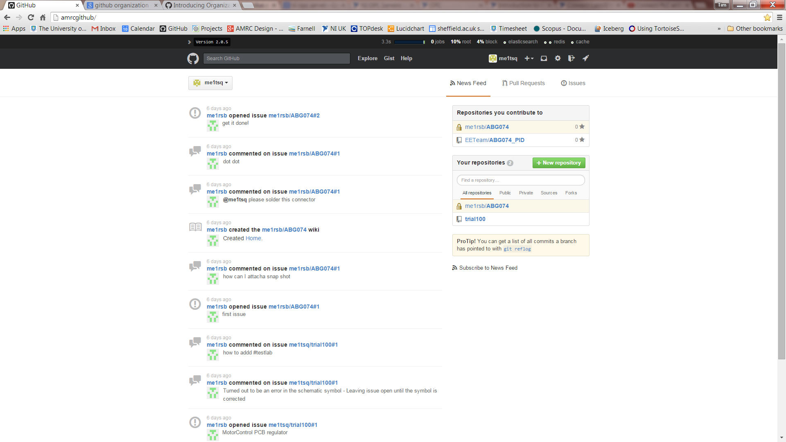

Figure 1 - News Feed Home Screen

Figure 2 – Setup your user profile, using “edit profile”. You can review activity, status of issues, repos etc..

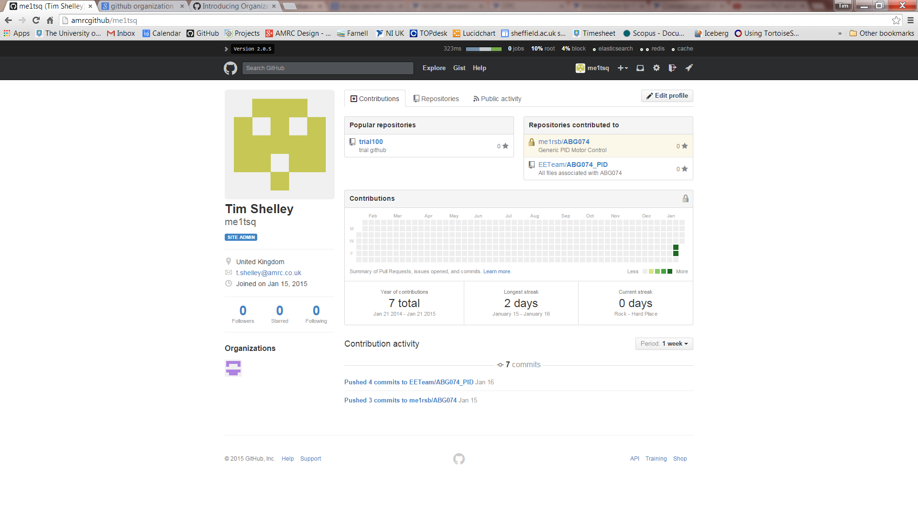

Figure 2 - User Profile

Figure 3, it is very simple to create a public/private repo, just add the repo name and a description and then get started.

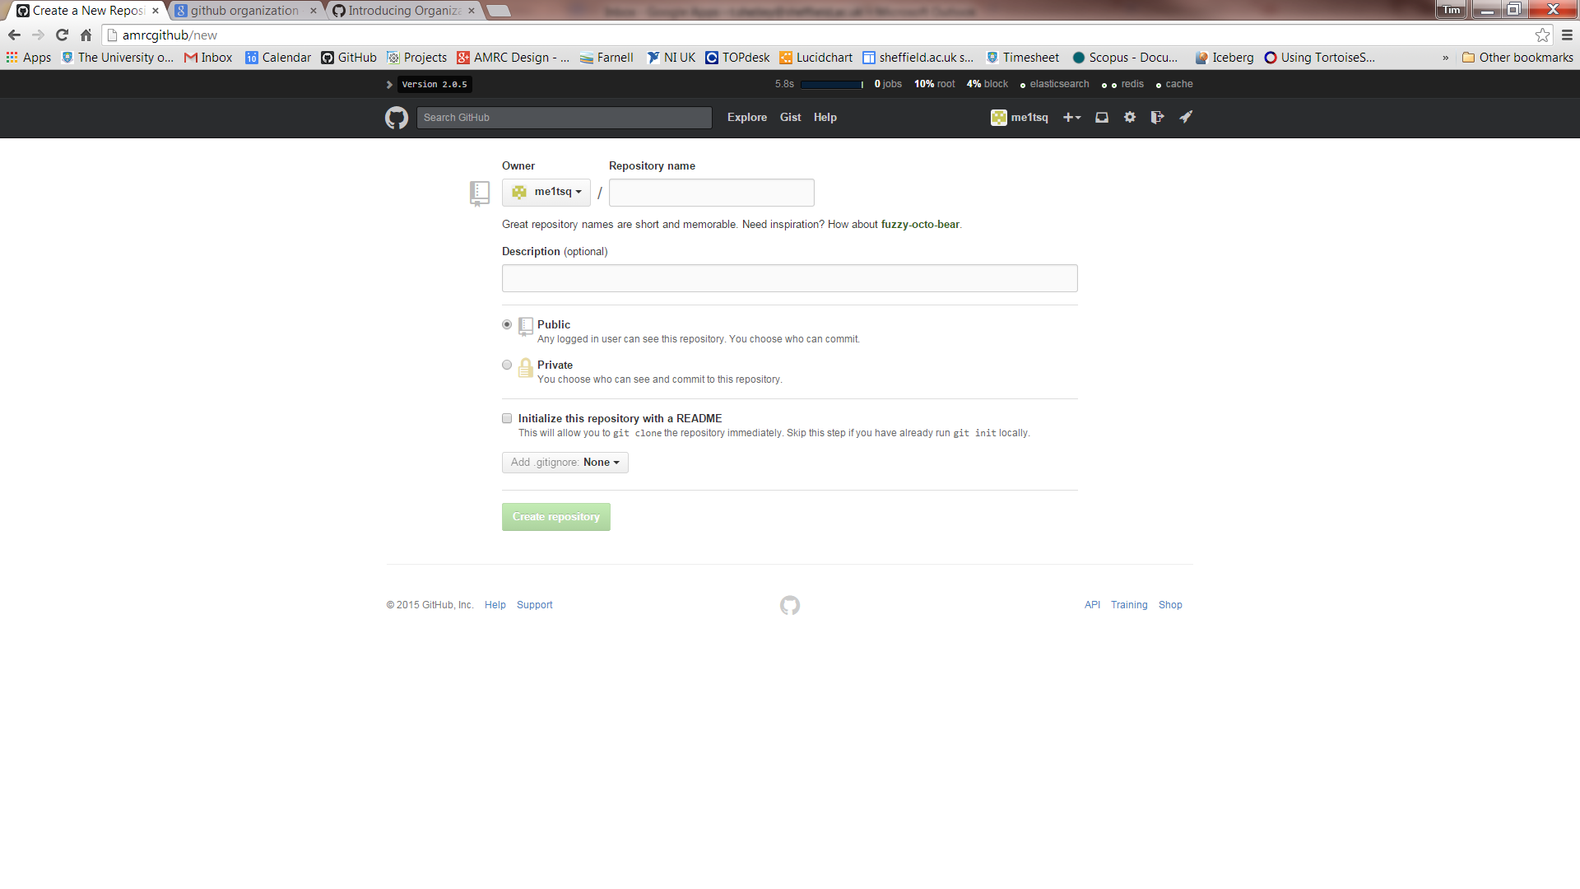

Figure 3 - Create Users Public/Private Repo

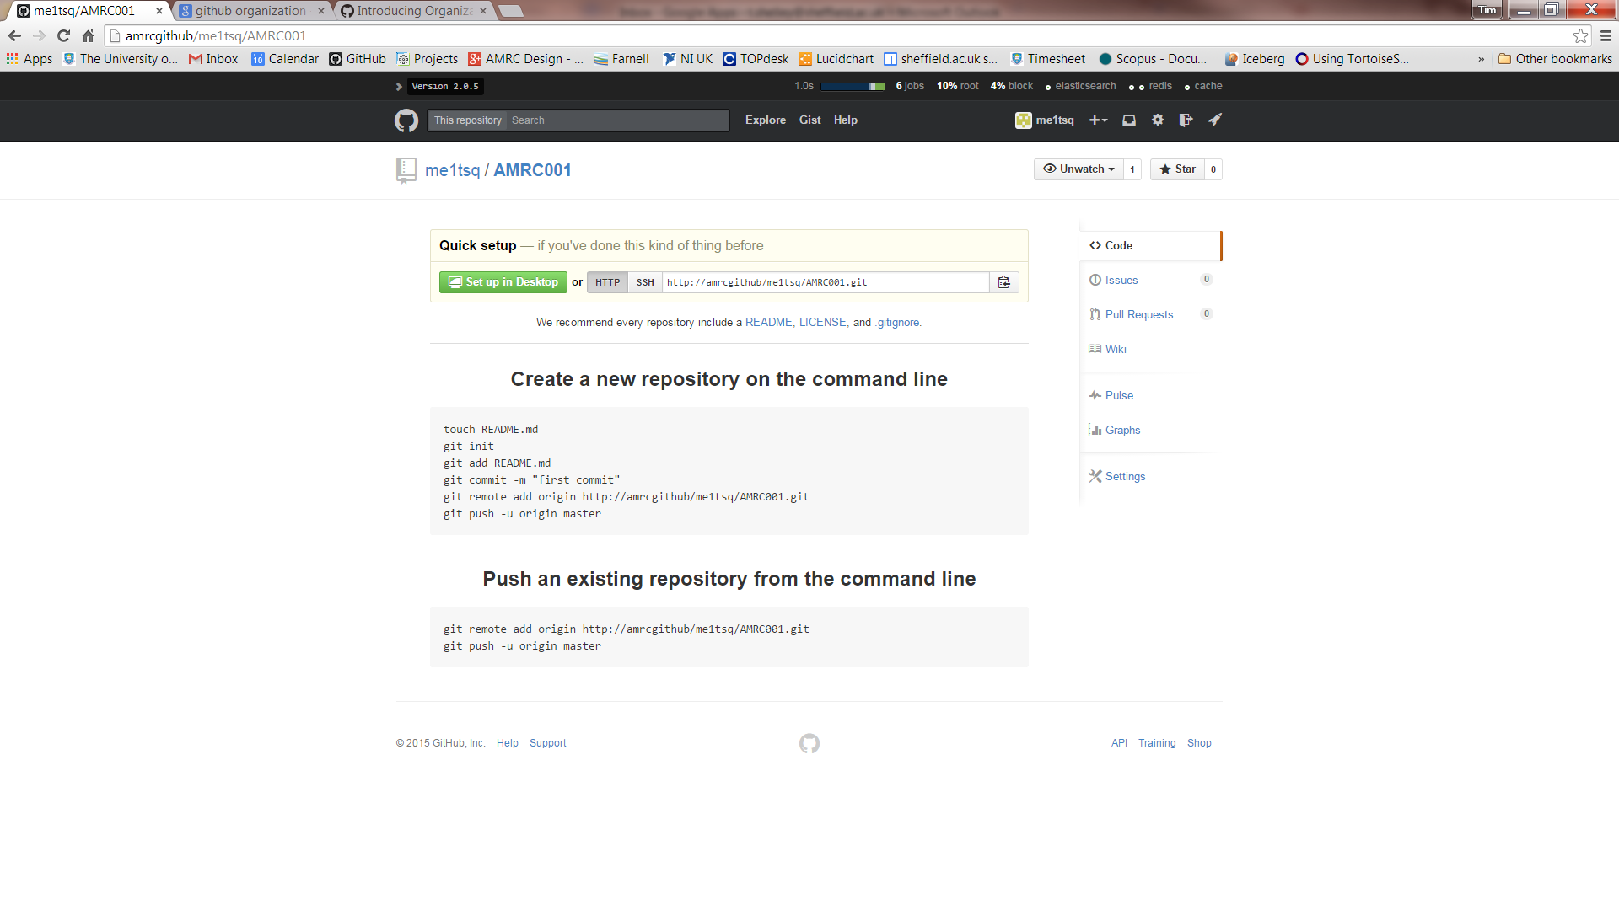

Figure 4 - AMRC001 Repo creation

Navigate to your local directory, create a new folder. Right click and **Git Init Here** this set the file up as a git repo, then navigate to Git Bash.

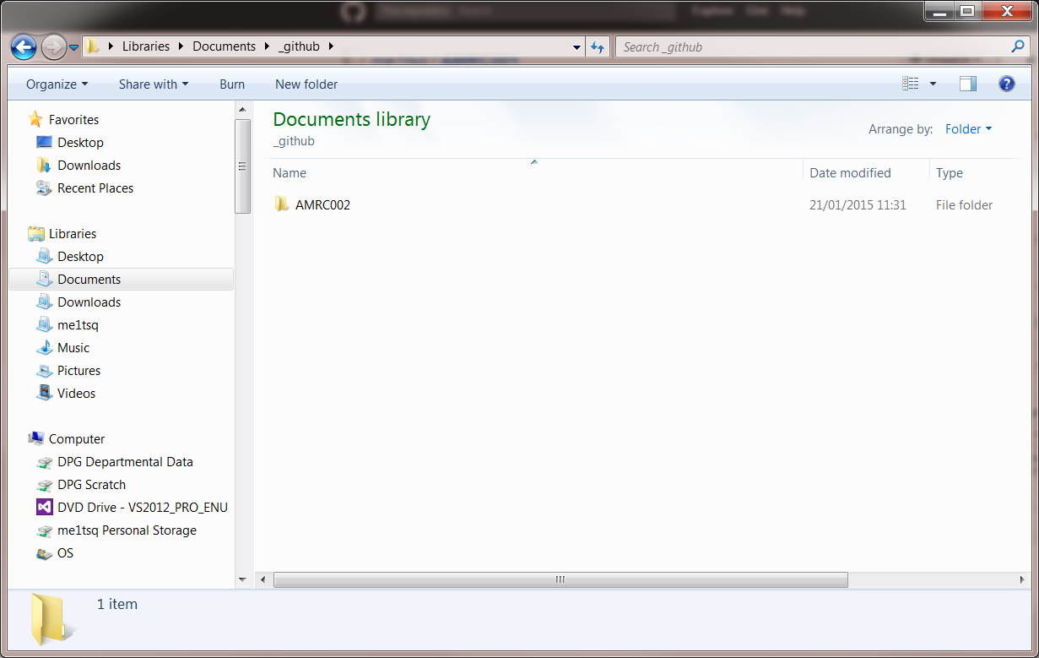

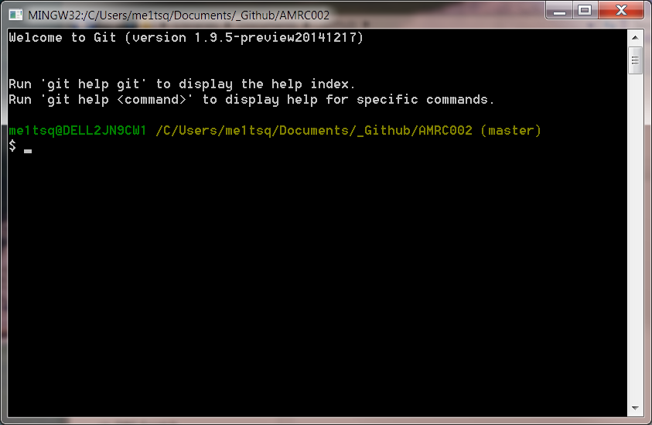

Git commands to create repo on <http://amrcgithub>.

***Touch readme.me***

***Git init***

***Git add README.md***

***Git add \****

***Git commit –m “AMRC002 first commit”***

***Git remote add origin*** [***http://amrcgithub/me1tsq/AMRC002.git***](http://amrcgithub/me1tsq/AMRC002.git)

***git push –u origin master***

I have added to new files and edited the readme.

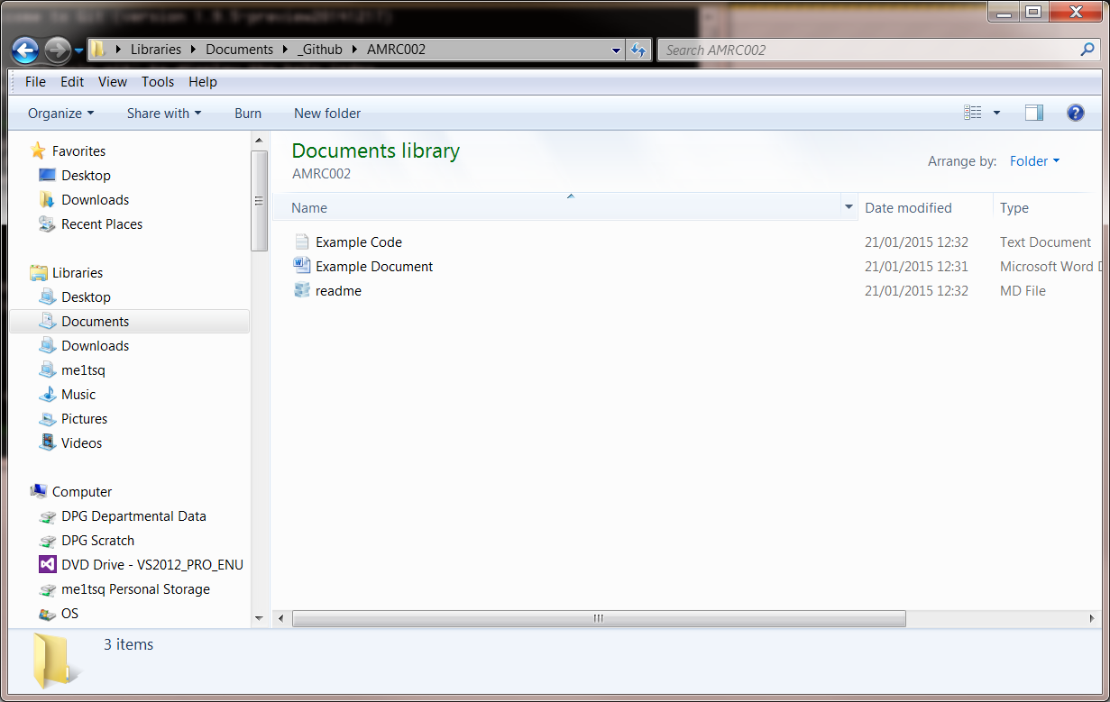

Open git bash..

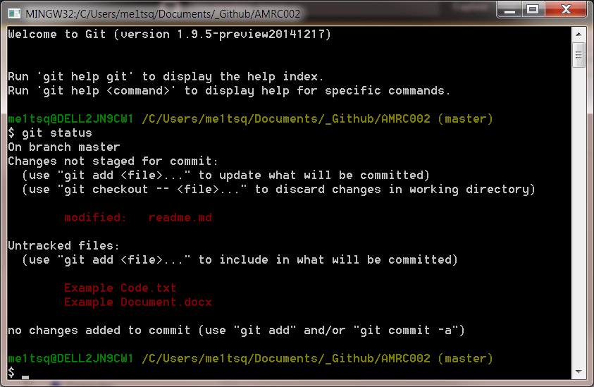

**Git status**

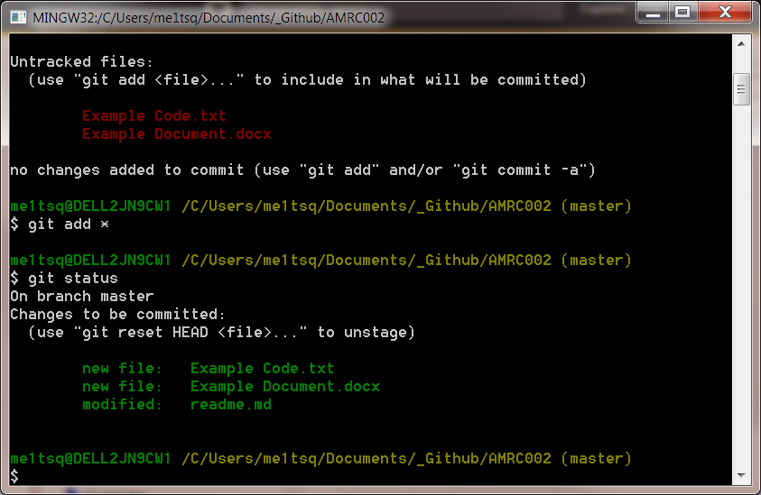

**After anny change use.**

**Git commit –m**

**Git add remote origin** [**http://amrcgithub/me1tsq/AMRC002.git**](http://amrcgithub/me1tsq/AMRC002.git)

**Git push –u origin master**

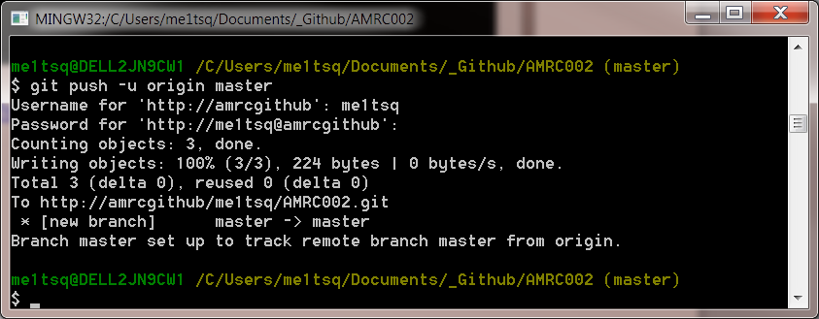

I then went onto github and made some changes to the source files and committed those changes.

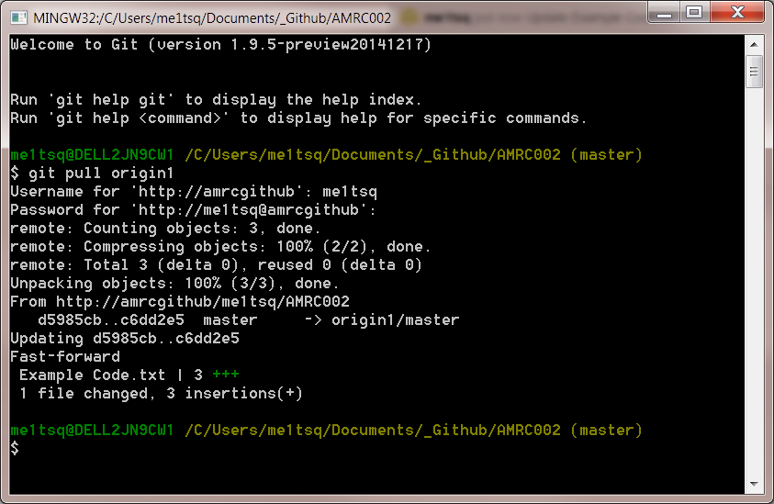

Using the ***git pull origin1***

**You can pull any online changes down to your local machine..**